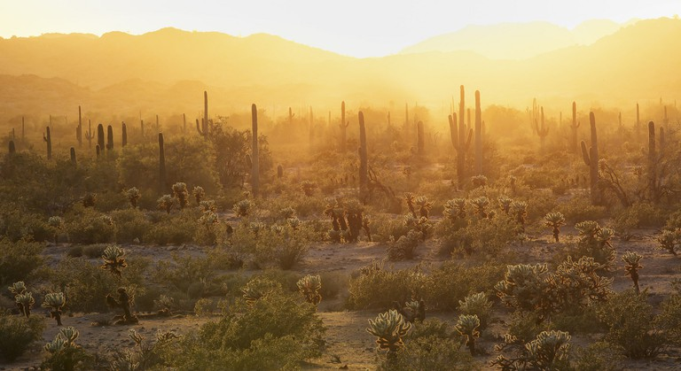

Sonoran Desert © Bureau of Land Management/Flickr